STATISTICS FOR BUSINESS ITAO 7100

Fazal Ur Rehman Cheema

40465466

WORD COUNT: 1432

Table of Contents
INTRODUCTION 3
Data Cleaning 3
Methodology 4
Conclusion 8
REFERENCES 9
LOGBOOK 10
REFLECTIVE COMMENTARY 11
DECLARATION ON GEN AI 11
APPENDIX 1 12

INTRODUCTION
Logistic regression is a commonly used statistical technique for modelling relationships where the outcome variable is categorical, particularly in cases involving binary decisions such as yes or no outcomes. It has been widely applied to problems including customer churn prediction, marketing response modelling, and credit risk assessment, as it allows organisations to estimate the probability of a specific outcome occurring based on observable characteristics (James et al., 2021). One important application is churn prediction, where identifying customers or employees likely to leave enables firms to implement targeted retention strategies and reduce recruitment and training costs (Verbeke et al., 2012). Similar principles apply in marketing and sales contexts, where predictive models are used to anticipate customer responses and optimise resource allocation.
In this study, logistic regression is applied to analyse the outcome of a term deposit sales campaign conducted by a financial institution. Using data from a previously run campaign, the objective is to predict whether a customer will subscribe to a term deposit based on characteristics such as age, contact method, previous campaign outcomes, and the timing of contact. This type of modelling has been shown to be effective in bank marketing applications, where customer response behaviour is influenced by demographic and interaction-related factors (Moro et al., 2014). From a practical perspective, sales teams are constrained by time and staffing limitations and cannot contact all customers within a large client base. Predictive modelling therefore provides a data-driven mechanism for prioritising customers with a higher likelihood of subscription and improving campaign efficiency.
Based on prior research on bank telemarketing response modelling, five bivariate hypotheses are specified to align with the variables available in the term deposit campaign data. Age, contact duration, contact method, previous campaign outcome, and month are each hypothesised to be associated with subscription, reflecting the influence of demographic characteristics, engagement intensity, communication channels, prior responsiveness, and seasonal timing on campaign success.

Data Cleaning
Based on prior research on bank telemarketing response modelling, five bivariate hypotheses are specified to align with the variables available in the term deposit campaign data. Age, contact duration, contact method, previous campaign outcome, and month are each hypothesised to be associated with subscription, reflecting the influence of demographic characteristics, engagement intensity, communication channels, prior responsiveness, and seasonal timing on campaign success.

Methodology
The data after being loaded into R was inspected using basic descriptive functions like running summary and string. This allowed for us to be able to inspect individual elements of the data as well as any relationships to work towards our hypotheses. First, we examine the subscribed column which is a key variable in our hypotheses. A simple bar chart shows the following:
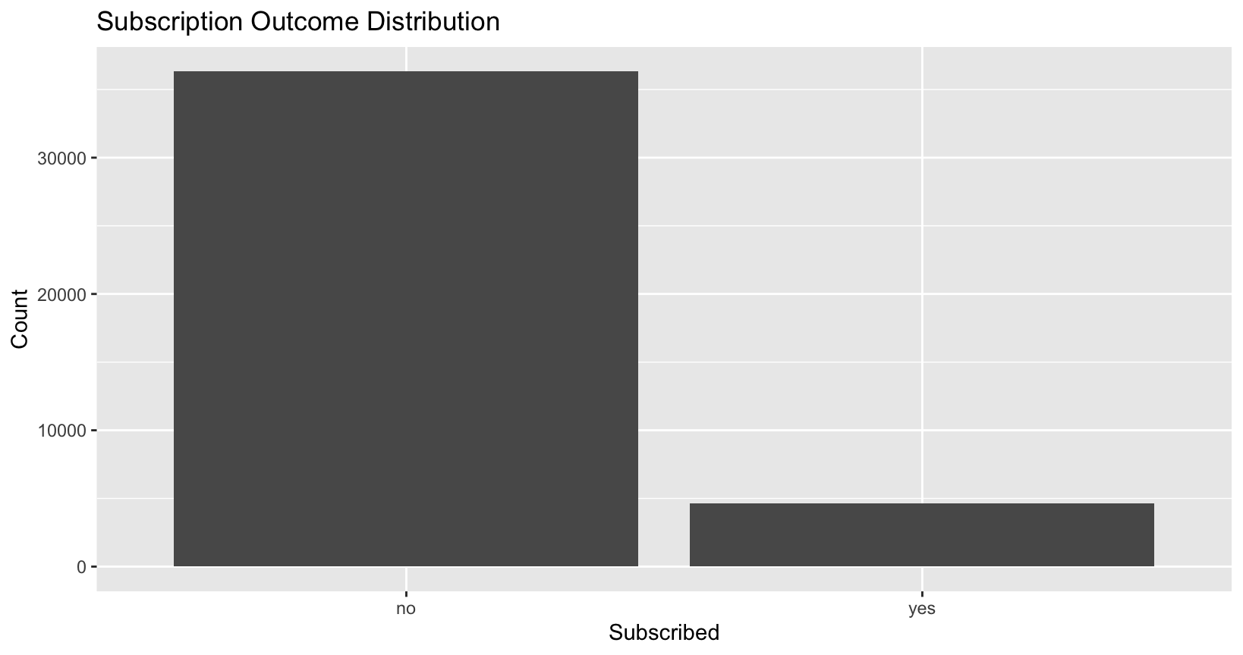Figure 1: Overall subscribed vs unsubscribed
We can see that a large majority of the customers targeted are unsubscribed and a fewer portion did subscribe. Overall, the aim would be to be able to isolate the factors that are driving them to subscribe.
An inspection of the age variable shows that age is that the data is right skewed with most customers middle aged:
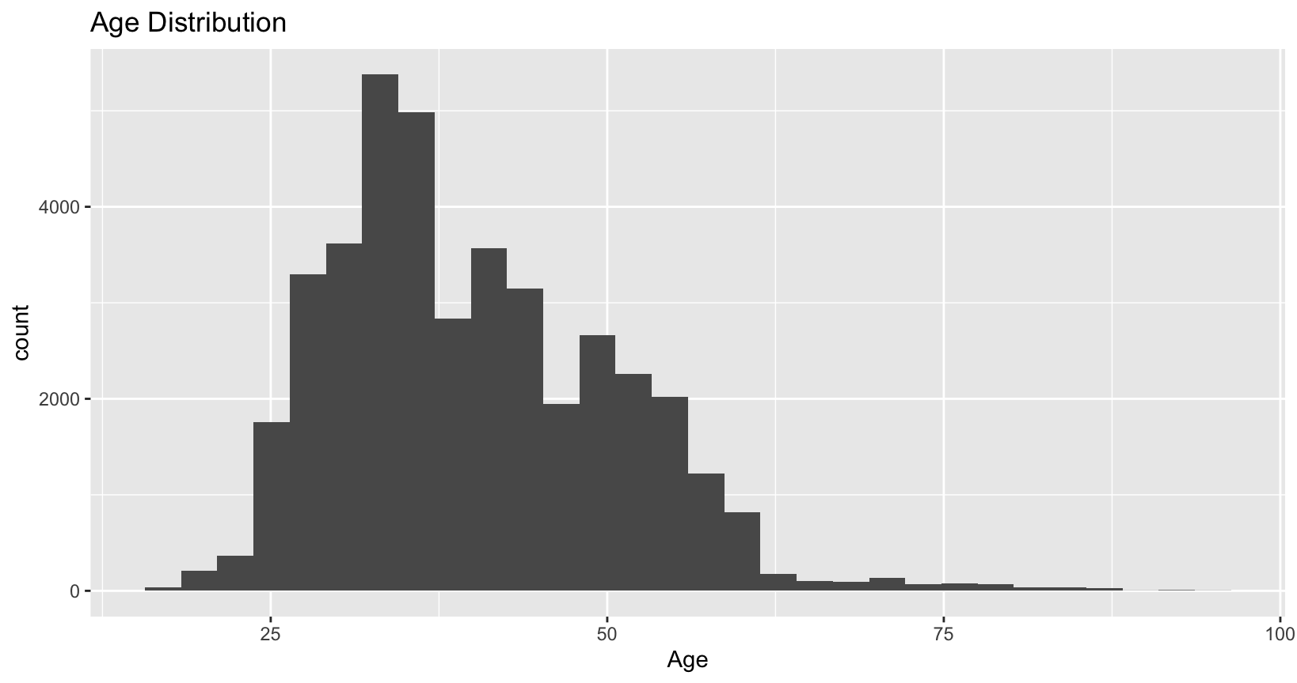
Figure 2: Age column
The column for contact duration shows that few calls took more than 15 minutes and were mostly less than 10 minutes.
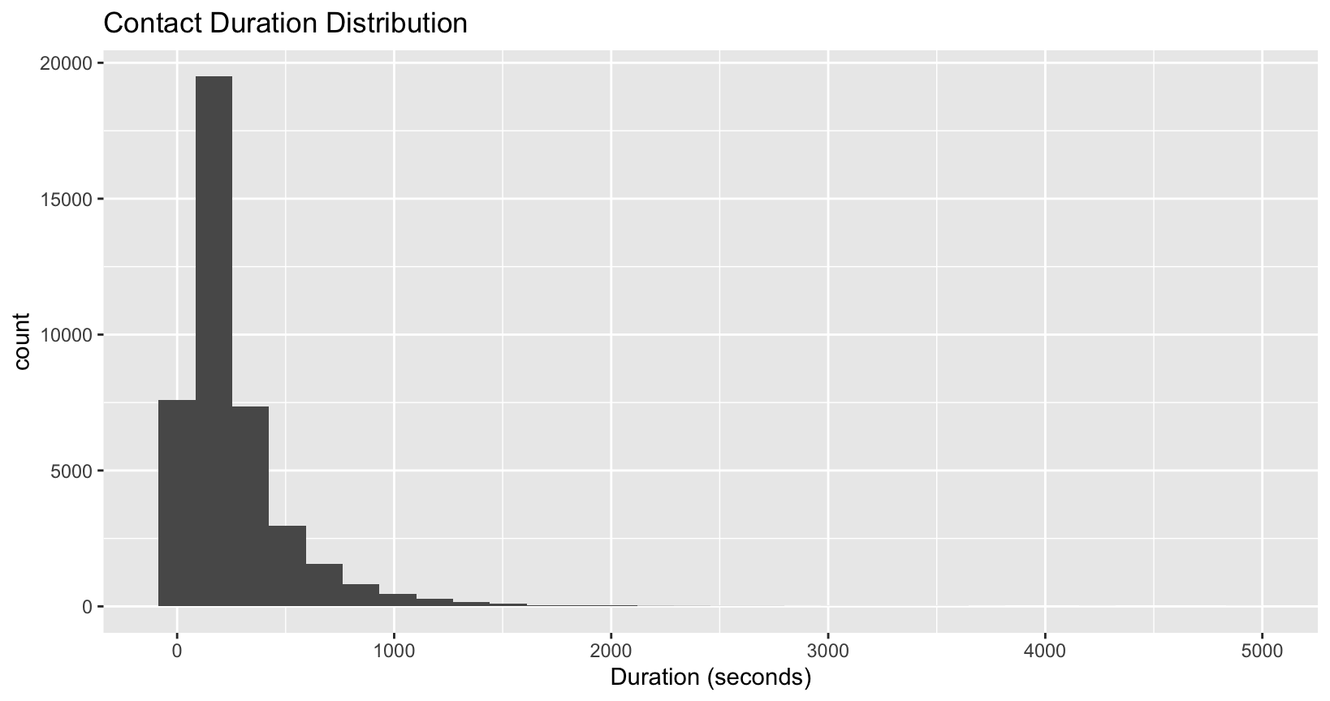Figure 3: Contact duration
If we plot the calls made by month, we can see that may was the prime for the sales calls as well as across the summers with November being the only month during the winter times that calls were significantly made. But mostly the campaigns ran through the summer months.

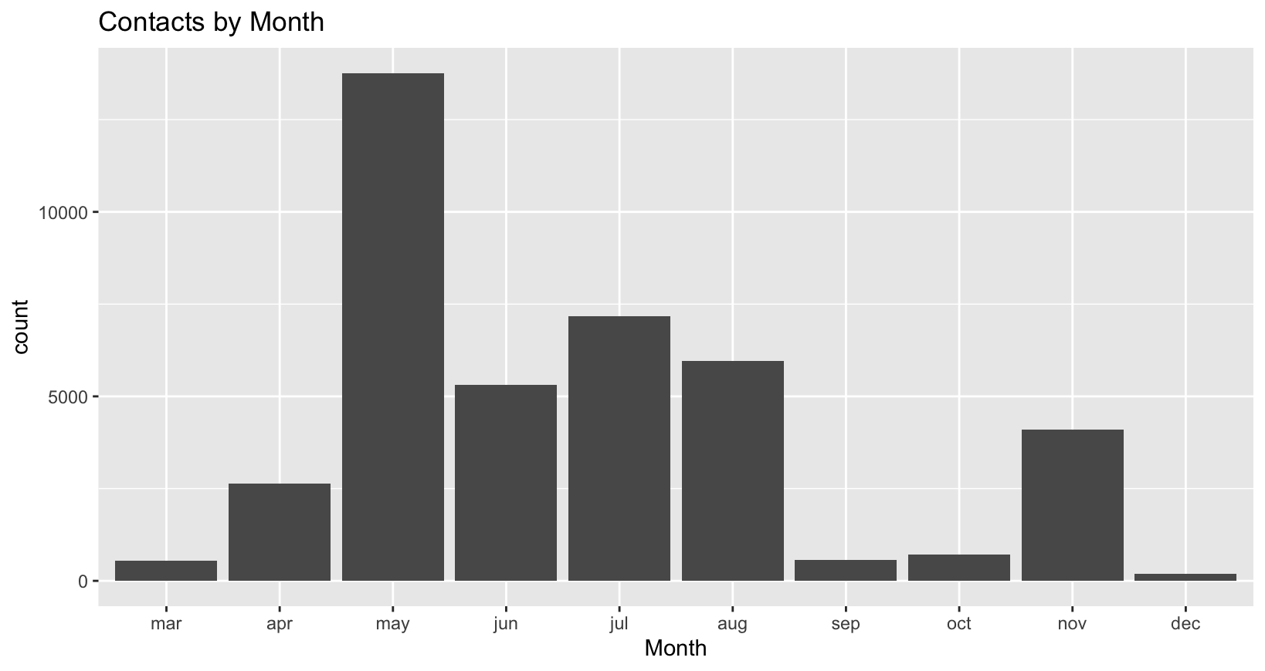
Figure 4: Contacts by month
We also see that an increased age is seen for the customers who ended up subscribing. Similarly, if we plot contact duration with subscribed, we can see a clear increase in the number of subscribers with a higher contact duration. This data also shows outliers, yet they are to remain for the regression model to show significant results.
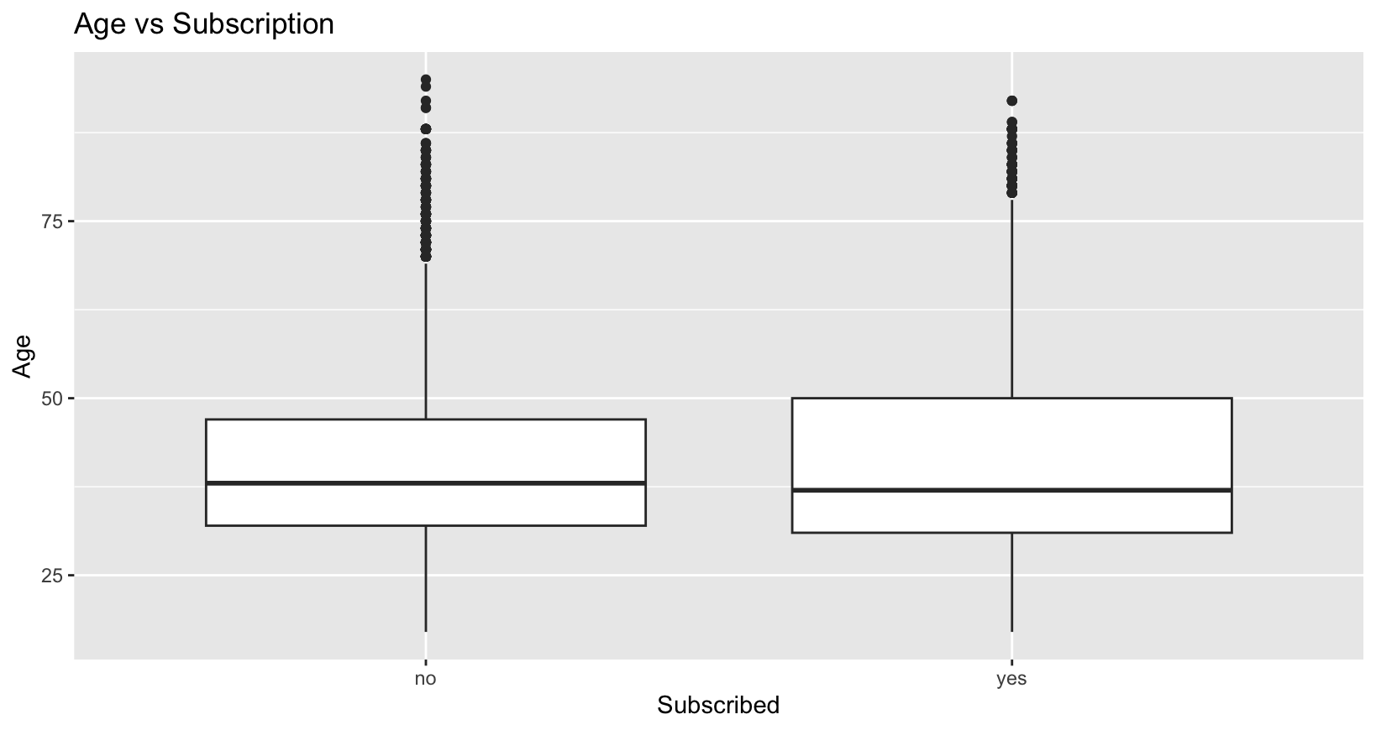
Figure 5: Age vs Subscription
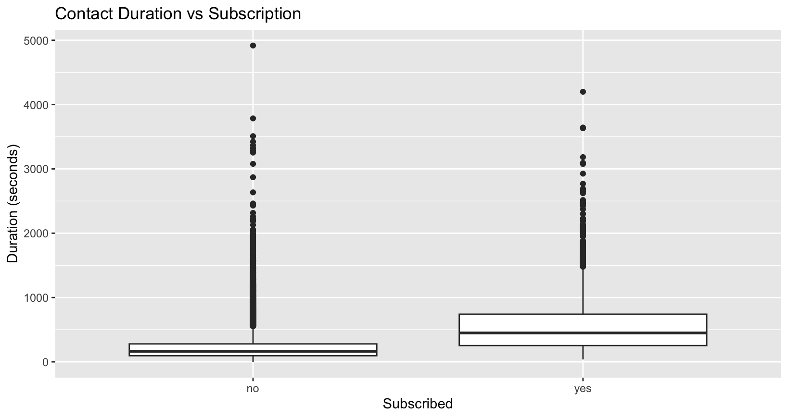
Figure 6: Contact Duration vs Subscription

The chi-squared test indicates a strong and statistically significant association between contact method and subscription outcome (χ² = 872.64, p < 0.001), suggesting that subscription rates differ meaningfully depending on how customers are contacted. Similarly, the relationship between previous campaign outcome and subscription is highly significant (χ² = 4196.7, p < 0.001), indicating that customers with different prior campaign experiences show significantly different probabilities of subscribing. In contrast, the chi-squared test for month versus subscription could not be computed, which is likely due to zero or very small cell counts in the contingency table, violating the assumptions of the chi-squared test. As a result, while descriptive patterns across months are explored visually, formal inference for the month variable is not there.
The binary nature of the dependant variable means that we have to use logistical regression to model the probability of the subscription. It estimates the log odds of the outcome as a linear function of the predictors. The dataset was partitioned into training (80%) and test (20%) sets using stratified sampling to preserve the distribution of the outcome. A baseline model(model1) using age, contact duration, contact method, and previous campaign outcome was built. This model showed strong explanatory power, with a pseudoR2 of 0.357 and an AIC value of 16608, indicating a substantial improvement over the null model. All predictors were statistically significant at 1% level. Particularly, previous campaign success increased the odds of subscription by a factor of around 12.9, while longer contact duration was also strongly associated with a higher subscription likelihood. Then we make an enhanced model that has additional variables such as month of contact and number of previous contacts. This model significantly improves upon the previous model, reducing the AIC to 15,401 and increasing the pseudoR2 to 0.416. These results indicate that incorporating seasonal and engagement related variables improves the explanatory power of the models. This is model2. Using a confusion matrix shows that overall accuracy increased to 90.6%, and balanced accuracy rose to 65.9%, reflecting improved classification of both subscribers and non-subscribers.
For real world deployment we make a third model that is estimated excluding contact-duration. Since, contact duration cannot be predicted beforehand. This means that we can urge the contact centre employees to maybe engage the customers more, but we cannot target or produce a shortlist of customers based on contact-time. So, in this model we exclude it. This model remains statistically valid, yet its performance declined, with a pseudorR2 of 0.203 and an AIC of 19,601. Indicating reduced predictive capability. However, this setting would be a more realistic pre-call decision making tool.

Conclusion
This study shows that customer subscription to term deposits can be effectively modelled using logistic regression, with contact duration, previous campaign outcomes, and contact method emerging as the strongest predictors. The enhanced model including contact duration achieves the best statistical performance as evidenced by the lowest AIC and highest pseudoR2 value. These results suggest that subscription behaviour is influenced not just by customer characteristics but also by timing and interaction frequency. There is a trade-off between predictive accuracy and practical applicability. While contact duration substantially improves model performance, it is not available before making a sales call and therefore limits real-world deployment. If excluded the predictive performance declines but the resulting model is deployable in a real-world scenario. We can use it to hit a sales target for Term-Deposits to keep the product functioning or predict whether a sales campaign would not be useful and if the product is not viable for the customer base anymore. These findings demonstrate how logistical regression can be used as a predictive and explanatory tool in marketing analytics. Future research could explore alternative classification techniques or cost-sensitive modelling approaches to further improve identification of potential subscribers.

REFERENCES
Agresti, A. (2013) Categorical Data Analysis. 3rd edn. Hoboken, NJ: Wiley. Available at: https://www.wiley.com/en-gb/Categorical%2BData%2BAnalysis%2C%2B3rd%2BEdition-p-9780470463635 (Accessed: 5 January 2026).

Cox, D.R. (1958) ‘The regression analysis of binary sequences’, Journal of the Royal Statistical Society: Series B (Methodological), 20(2), pp. 215–232. https://doi.org/10.1111/j.2517-6161.1958.tb00292.x Available at: https://academic.oup.com/jrsssb/article/20/2/215/7027376 (Accessed: 5 January 2026).

Fawcett, T. (2006) ‘An introduction to ROC analysis’, Pattern Recognition Letters, 27(8), pp. 861–874. https://doi.org/10.1016/j.patrec.2005.10.010 Available at: https://www.sciencedirect.com/science/article/pii/S016786550500303X (Accessed: 5 January 2026).

Fox, J. and Weisberg, S. (2024) car: Companion to Applied Regression. R package. Available at: https://cran.r-project.org/package=car (Accessed: 5 January 2026).

Harrell, F.E. (2015) Regression Modeling Strategies: With Applications to Linear Models, Logistic Regression, and Survival Analysis. 2nd edn. Cham: Springer. Available at: https://link.springer.com/book/10.1007/978-3-319-19425-7 (Accessed: 5 January 2026).

Hlavac, M. (2022) stargazer: Well-Formatted Regression and Summary Statistics Tables. R package. Available at: https://CRAN.R-project.org/package=stargazer (Accessed: 5 January 2026).

Hosmer, D.W., Lemeshow, S. and Sturdivant, R.X. (2013) Applied Logistic Regression. 3rd edn. Hoboken, NJ: Wiley. https://doi.org/10.1002/9781118548387 Available at: https://onlinelibrary.wiley.com/doi/book/10.1002/9781118548387 (Accessed: 5 January 2026).

James, G., Witten, D., Hastie, T. and Tibshirani, R. (2021) An Introduction to Statistical Learning: With Applications in R. 2nd edn. Cham: Springer. https://doi.org/10.1007/978-1-0716-1418-1 Available at: https://www.statlearning.com/ (Accessed: 5 January 2026).

Kuhn, M. (2008) ‘Building predictive models in R using the caret package’, Journal of Statistical Software, 28(5), pp. 1–26. https://doi.org/10.18637/jss.v028.i05 Available at: https://www.jstatsoft.org/article/view/v028i05 (Accessed: 5 January 2026).

McCullagh, P. and Nelder, J.A. (1989) Generalized Linear Models. 2nd edn. London: Chapman & Hall. Available at: https://books.google.co.uk/books/about/Generalized_Linear_Models_Second_Edition.html?id=h9kFH2_FfBkC (Accessed: 5 January 2026).

Moro, S., Cortez, P. and Rita, P. (2014) ‘A data-driven approach to predict the success of bank telemarketing’, Decision Support Systems, 62, pp. 22–31. https://doi.org/10.1016/j.dss.2014.03.001 Available at: https://www.sciencedirect.com/science/article/abs/pii/S016792361400061X (Accessed: 5 January 2026).

Nagelkerke, N.J.D. (1991) ‘A note on a general definition of the coefficient of determination’, Biometrika, 78(3), pp. 691–692. https://doi.org/10.1093/biomet/78.3.691 Available at: https://academic.oup.com/biomet/article/78/3/691/246268 (Accessed: 5 January 2026).

R Core Team (2025) R: A language and environment for statistical computing. Vienna: R Foundation for Statistical Computing. Available at: https://www.R-project.org/ (Accessed: 5 January 2026).

Verbeke, W., Dejaeger, K., Martens, D., Hur, J. and Baesens, B. (2012) ‘New insights into churn prediction in the telecommunication sector: A profit driven data mining approach’, European Journal of Operational Research, 218(1), pp. 211–229. https://doi.org/10.1016/j.ejor.2011.09.031 Available at: https://ideas.repec.org/a/eee/ejores/v218y2012i1p211-229.html (Accessed: 5 January 2026).

Wickham, H. (2016) ggplot2: Elegant Graphics for Data Analysis. 2nd edn. Cham: Springer. Available at: https://link.springer.com/book/10.1007/978-3-319-24277-4 (Accessed: 5 January 2026).

Wickham, H., Averick, M., Bryan, J., Chang, W., McGowan, L.D., François, R., Grolemund, G., Hayes, A., Henry, L., Hester, J., Kuhn, M., Pedersen, T.L., Miller, E., Bache, S.M., Müller, K., Ooms, J., Robinson, D., Seidel, D.P., Spinu, V., Takahashi, K., Vaughan, D., Wilke, C., Woo, K. and Yutani, H. (2019) ‘Welcome to the tidyverse’, Journal of Open Source Software, 4(43), 1686. https://doi.org/10.21105/joss.01686 Available at: https://joss.theoj.org/papers/10.21105/joss.01686 (Accessed: 5 January 2026).

LOGBOOK

Stage 1: Data exploration and quality.
Date: 23-24 December 2025.
According to the feedback that I received the outlier removal was not favourable for my previous work and so this time not being sure on what to do I inspected the outliers after initially inspecting and cleaning the data by removing Nas but left them in the data as they were going to be a feature of the data itself and were going to help me build a stronger more robust model.

Stage 2: Data Visualisation
Date 27-31 December 2025.
Key challenges again were that the dependant variable being categorical I could not create line charts, but I used bar graphs to have an initial look of the columns that I had shortlisted as well as to be able to see their skewness. This was useful for descriptive statistics and some boxplots allowed as an indicator of bivariate relationships for the data. But overall, this is the easiest as I have now gotten used to making visualisations using ggplot.
Stage 3: Measures of Association
Date: 29th December 2025 – 1st December 2026
This was the most challenging part since I did not know apart from the chi squared test on what measures of association to use but the chi squared test proved to be very useful and helped me gauged the significance for each of the variables I was using in my regression. I also found out other tests, but I did not know how to use them nor did I know how to interpret them, so I left them be and stuck to the chi squared test.

Stage 4: Regression and Prediction
Date: 2d Jan 2026 – 4th January 2026.
I build my model and kept using the results to improve my model. After adding a few additional variables, I felt that it was not realistic to build a model based on contact duration since we have don’t have contact duration before a campaign starts. My previous experience in business development working in sales helped me a lot in my work as well. So, I built a final model which was weaker overall but could actually be put to use to shortlist customer and create a targeted campaign.

REFLECTIVE COMMENTARY
This time around I knew what had to be done so I got to the point of the code, did not have to do much exploration or learning as I knew what I was doing and I used it to my advantage to write clean and neat code and not overcomplicate things. There were times where I was going to go completely off track with my work, but I went back and recentred around the core objectives to keep myself focused. There are just a lot of opportunities and different ways to implement these concepts in business settings that it makes you distracted, and you are always considering different scenarios. Some work is tedious and repetitive which makes you want to be able to overcome this by using other tools and get better results but at the same time you get hands on experience in coding which is almost always very useful. Overall, with practice this process would be mastered, and I would want for my primary coding language to be R so that I can master it, demonstrate it, and use it effectively.

DECLARATION ON GEN AI
ChatGPT was used in this work as a guide, an assistant, where it would augment everything, I was doing while writing code or my report to help me achieve my objectives quickly and efficiently. I used it to get back on track if I had forgotten a key concept, a code snippet, or got lost in what was appropriate for me to do or not. I used it to edit and proofread my work after I had written it and for general titbits and guidance when approaching any of the topics that I have delved into above. I used it to look up literature and to format my bibliography for me as well as sometimes I would use it to interpret the results of my models as to exactly what they meant and how could they be interpreted and improved. Overall, it made me more efficient, accurate, and precise in my work.

APPENDIX 1

######## Term Deposit Data ###############################

######## Data loaded using the Global Environment #################

### set working directory ######################
getwd()

### Installing the appropriate packages ##########
install.packages("tidyverse")
install.packages("ggplot2")
install.packages("caret")

### Initial look at the data #########
summary(termsv)
str(termsv)

### DATA CLEANING #####
### Checking for missing values ######
sum(is.na(termsv))

### 25 NAs found ##### Since number is low will be omitting rows with NAs ####
termsv <- na.omit(termsv)

sum(is.na(termsv))

### Checking and fixing data types ##########
str(termsv)

#### Trimming white space in all character columns #####
#### This code snippet is taken from ChatGPT ##########
#### It uses sapply and lapply to apply trimws on the columns #####
char_cols <- sapply(termsv, is.character)
termsv[char_cols] <- lapply(termsv[char_cols], trimws)

### There are inconsistent names in the month and day columns ######
if ("month" %in% names(termsv)) {termsv$month[termsv$month == "july"] <- "jul"}
if ("day" %in% names(termsv)) {termsv$day[termsv$day == "friday"] <- "fri"}

#### Now to select the column types manually for each column ######
termsv$ID <- as.integer(termsv$ID)
termsv$age <- as.integer(termsv$age)
termsv$contact_duration <- as.integer(termsv$contact_duration)
termsv$number_contacts <- as.integer(termsv$number_contacts)
termsv$last_contacted <- as.integer(termsv$last_contacted)
termsv$prev_contacts <- as.integer(termsv$prev_contacts)
termsv$empl_var_rate <- as.numeric(termsv$empl_var_rate)
termsv$cons_price_index <- as.numeric(termsv$cons_price_index)
termsv$cons_conf_index <- as.numeric(termsv$cons_conf_index)
termsv$euribor_three_mth <- as.numeric(termsv$euribor_three_mth)
termsv$nr_employed <- as.numeric(termsv$nr_employed)
termsv$subscribed <- as.factor(termsv$subscribed)
termsv$gender <- as.factor(termsv$gender)
termsv$occupation <- as.factor(termsv$occupation)
termsv$salary_level <- as.factor(termsv$salary_level)
termsv$marital_status <- as.factor(termsv$marital_status)
termsv$education_level <- as.factor(termsv$education_level)
termsv$credit_default <- as.factor(termsv$credit_default)
termsv$has_mortgage <- as.factor(termsv$has_mortgage)
termsv$has_personal_loan <- as.factor(termsv$has_personal_loan)
termsv$has_car_insurance <- as.factor(termsv$has_car_insurance)
termsv$has_life_insurance <- as.factor(termsv$has_life_insurance)
termsv$has_savings_account <- as.factor(termsv$has_savings_account)
termsv$has_current_account <- as.factor(termsv$has_current_account)
termsv$has_credit_card <- as.factor(termsv$has_credit_card)
termsv$contact_method <- as.factor(termsv$contact_method)
termsv$month <- as.factor(termsv$month)
termsv$day <- as.factor(termsv$day)
termsv$prev_campaign_outcome <- as.factor(termsv$prev_campaign_outcome)

str(termsv)

######### DESCRIPTIVE STATISTICS #############################
summary(termsv)

######### Initial descriptive plots. #######################

install.packages("ggplot2")
library(ggplot2)

### First we plot the target variable subscribed #########
#### This allows us to see the distribution of the target variable #########
ggplot(termsv, aes(x = subscribed)) +
geom_bar() +
labs(title = "Subscription Outcome Distribution",
x = "Subscribed", y = "Count")

#### Now we plot the numeric variables of interest to have an initial view ####

ggplot(termsv, aes(x = age)) +
geom_histogram(bins = 30) +
labs(title = "Age Distribution", x = "Age")

ggplot(termsv, aes(x = contact_duration)) +
geom_histogram(bins = 30) +
labs(title = "Contact Duration Distribution", x = "Duration (seconds)")

ggplot(termsv, aes(x = contact_method)) +
geom_bar() +
labs(title = "Contact Method Frequency", x = "Contact Method") +
theme(axis.text.x = element_text(angle = 45, hjust = 1))

termsv$month <- factor(
termsv$month,
levels = c("jan","feb","mar","apr","may","jun",
"jul","aug","sep","oct","nov","dec")
)

ggplot(termsv, aes(x = month)) +
geom_bar() +
labs(title = "Contacts by Month", x = "Month")

ggplot(termsv, aes(x = subscribed, y = age)) +
geom_boxplot() +
labs(title = "Age vs Subscription", x = "Subscribed", y = "Age")

ggplot(termsv, aes(x = subscribed, y = contact_duration)) +
geom_boxplot() +
labs(title = "Contact Duration vs Subscription",
x = "Subscribed", y = "Duration (seconds)")

### CHECKING BIVARIATE RELATIONSHIPS #################################

#### THE FOUR RELATIONSHIPS TO BE TESTED ARE #######################
### AGE VS SUBSCRIPTION########
### CONTACT DURATION VS SUBSCRIPTION #######################
### CONTACT METHOD VS SUBSCRIPTION #########################
### PREVIOUS CAMPAIGN OUTCOME VS SUBSCRIPTION ##############
### MONTH VS SBSCRIPTION ###################################

### BOXPLOT FOR AGE VS SUBSCRIPTION ########################
### CORRELATION NOT APPROPRIATE BECAUSE IT THE DEPENDANT VARIABLE IS BIANRY ####
boxplot(age ~ subscribed,
data = termsv,
main = "Age by Subscription Outcome",
xlab = "Subscribed",
ylab = "Age")

### BOXPLOT FOR CONTACT DURATION VS SUBSCRIPTION ############
boxplot(contact_duration ~ subscribed,
data = termsv,
main = "Contact Duration by Subscription Outcome",
xlab = "Subscribed",
ylab = "Contact Duration (seconds)")

### CHISQUARED TEST FOR CONTACT METHOD VS SUBSCRIPTION ######
chisq.test(table(termsv$contact_method, termsv$subscribed))

### CHISQUARED TEST FOR CAMPAIGN OUTCOME VS SUBSCRIPTION ####
chisq.test(table(termsv$prev_campaign_outcome, termsv$subscribed))

### CHISQUARED TEST FOR MONTH VS SUBSCRIPTION ###############
chisq.test(table(termsv$month, termsv$subscribed))

#### BASELINE LOGISTICAL REGRESSION MODEL ####################

### SPLITTING DATA ###########################################
set.seed(40465466)
library(caret)

partition <- createDataPartition(termsv$subscribed, p = 0.8, list = FALSE)
train <- termsv[partition,]
test <- termsv[-partition,]

model <- glm(subscribed ~ age + contact_duration + contact_method + prev_campaign_outcome, data = train, family = binomial)

summary(model)

##### checking model accuracy and assumption testing ##########

### Interpreting coefficients using odds ratios ##########
exp(coef(model))

### Confidence intervals for odds ratios ################
exp(confint(model))

### Assessing overall model fit using PseudoR2 ####
### using this function from the class handout on Logistical Regression ####

logisticPseudoR2s <- function(LogModel) {
dev <- LogModel$deviance
nullDev <- LogModel$null.deviance
modelN <- length(LogModel$fitted.values)

R.l <- 1 - dev / nullDev
R.cs <- 1 - exp(-(nullDev - dev) / modelN)
R.n <- R.cs / (1 - exp(-(nullDev / modelN)))

cat("Pseudo R^2\n",
"Hosmer–Lemeshow:", round(R.l, 3), "\n",
"Cox & Snell:", round(R.cs, 3), "\n",
"Nagelkerke:", round(R.n, 3), "\n")
}

logisticPseudoR2s(model)

###### Checking for multicolinearity ###########

library(car)
vif(model)

####### Using Stargazer toget a table for the first model #####

install.packages("stargazer")
library(stargazer)

stargazer(
model,
type = "text",
title = "Logistic Regression Results: Subscription Model",
dep.var.labels = "Subscribed (Yes = 1)",
covariate.labels = c("Age", "Contact Duration", "Contact Method", "Previous Campaign Outcome"),
digits = 3
)

##### Odds ratio in stargazer ############
stargazer(
model,
type = "text",
apply.coef = exp,
apply.se = exp,
title = "Logistic Regression (Odds Ratios)"
)

########## BUILDING A MODEL USING MULTIPLE VARIABLES ######

model2 <- glm(
subscribed ~ age + contact_duration + contact_method + prev_campaign_outcome +
month + number_contacts,
data = train,
family = binomial )

summary(model2)

###### Comparing model 2 with model 1 ############################

AIC(model2)

logisticPseudoR2s(model2)

library(car)
vif(model2)

train$pred_prob_m2 <- fitted(model2)
head(train[, c("pred_prob_m2", "subscribed")])

pred_prob_m2 <- predict(model2, test, type = "response")
class_pred_m2 <- as.factor(ifelse(pred_prob_m2 > 0.5, "yes", "no"))

library(caret)
confusionMatrix(class_pred_m2, test$subscribed)

train$std_resid_m2 <- rstandard(model2)
sum(abs(train$std_resid_m2) > 1.96)

sum(cooks.distance(model2) > 1)

############# Model 3 (this one excludes contact_duration) ############

####### Model 3: Realistic / deployable (excludes contact_duration)####
model3 <- glm(
subscribed ~ age + contact_method + prev_campaign_outcome +
month + number_contacts,
data = train,
family = binomial
)

summary(model3)

##### Results (same set as model2) #########
AIC(model3)
logisticPseudoR2s(model3)

library(car)
vif(model3)

pred_prob_m3 <- predict(model3, test, type = "response")
class_pred_m3 <- as.factor(ifelse(pred_prob_m3 > 0.5, "yes", "no"))

library(caret)
confusionMatrix(class_pred_m3, test$subscribed)

train$std_resid_m3 <- rstandard(model3)
sum(abs(train$std_resid_m3) > 1.96)

sum(cooks.distance(model3) > 1)

###############################################################################
###############################################################################

